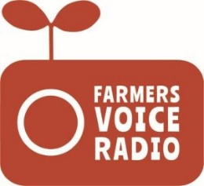

Farmers’ Voice Radio:
Listener Group meeting report template

Community
Date(s) of meeting
Names and designations of all participants | Include any other invited stakeholders
Topics covered for radio programme recordings

Feedback on radio programmes broadcast since the last LG meeting
Comments/suggestions regarding content, radio signal, topics, quality etc.

Reported changes arising as a result of the radio programmes
Changes to attitudes, knowledge and behaviour/practice taking place within the listener group or reported by members of the wider community, with a particular focus on adoption of forest-positive cocoa production practices.

Include quotes and photos (providing verbal consent has been given) where possible.

Summary of discussions around focus topics for radio recordings
Topics and issues to be covered in next round of recordings
Include any requests for additional stakeholder/technical input and how this will be sourced

