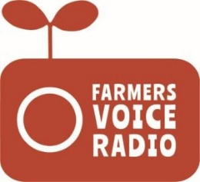
Farmers’ Voice Radio: Case Study Template
Try to gather at least one case study per community for each round of
Programme Reference Group meetings

Community
Date of case study
Interviewer’s name
Subject’s name
Subject’s role in project | i.e. Programme Reference Group member, farmer listener, extension officer, radio presenter, other stakeholder
Brief profile of subject | i.e. age, gender, marital status & number of children, any disability, size of smallholding, main livelihood activities (crops, livestock, off-farm), involvement in production of focus crop etc.

How do you usually get information and knowledge about issues significant to your cocoa farming and other livelihood activities?
What are the good and bad things about these sources of information?
What is your experience with the [insert name of programme] radio programmes?
- What prompted you to tune in?
- How long have you been listening?
- How frequently do you listen?
- Where/how do you listen? (own home, in someone else’s home, communally etc.)

How have you found the [insert name of programme] radio programmes?
Please prompt on issues related to:
- content (relevance, accuracy, timing, ease of understanding and applicability etc.)
- quality of recordings
- skills and knowledge of presenters, extension officers, other stakeholders
- access (radio reception, timing of broadcast, access to radio)

What is the best piece of information or knowledge you have gained from the radio programmes and how have you applied this learning? What changes have arisen as a result?
What would you change about the radio programmes, if anything?
- Anything you would like more/less of?
- Anything you would add?
- Anything you would do differently?

What would you say to other groups of farmers considering starting a similar radio programme?

